Physical Education (PE) UNIFORMS
2017-2018 SCHOOL YEAR

PE uniforms, consisting of navy blue shorts and a white t-shirt, are required for all PE classes (except kindergarten).
Dry-fit PE kits with the official ASP logo are available for purchase online via the ASP Community Portal on the ASP website. Alternatively, students may bring their own white t-shirt (athletic shirt, no large logos or writing) and blue shorts.
As per PE program policies, students must be properly attired by Monday September 15th 2017.

PLEASE MAKE SURE TO MARK YOUR CHILD’S NAME IN BOTH THE SHIRT AND SHORTS.

Yours in sport

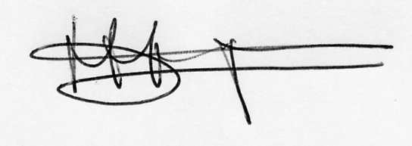
HAN HOEGEN
Athletic Director

