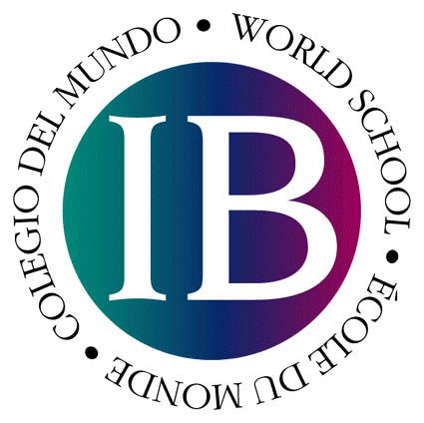
INTERNATIONAL BACCALAUREATE
May 2019
REGISTRATION INFORMATION
AND FORMS

You must return your completed registration form(s) along with payment to Ms. Pierce as soon as possible. Final deadline for registrations is: October 18th (SEPTEMBER 25th for IB Diploma Candidates)

Any questions? Please write to Ms.Pierce, Academic Dean
E – mail: apierce@asparis.fr

The IB Fees: All IB fees cover costs of preparing and grading the exams, administrative time, and the hiring of proctors. As employers will often give reimbursements for these fees, ask for a receipt if this is needed.

Payment: Please make payment by cash or by check made out to ASP.

Diploma and Certificate Candidates
VERY IMPORTANT FOR 2019 IBDP CANDIDATES: IF YOU REGISTERED FOR AN ANTICIPATED EXAMINATION LAST YEAR, YOU DO NOT NEED TO PAY THE REGISTRATION FEE THIS YEAR.

Registration = 225 €, then each exam = 130 €
1 exam 355 € (registration fee + 130 exam fee)
2 exams 485 €
3 exams 615 €
4 exams 745 €
5 exams 875 €
6 exams 1005 €

NB: If you are taking TOK and the EE as retake subjects, these will be charged at
90€ each.

IB Examination Registration Form
IT IS VERY IMPORTANT THAT ALL INFORMATION BE
PROVIDED. WE WILL BE UNABLE TO REGISTER YOU
WITHOUT ALL INFORMATION.

First name Middle name Last name |  |  |  |  | Date of birth:  day month year |  |  |  | Gender: M/F
Nationality 1 |  |  |  | Nationality 2
1st language |  |  |  | 2nd language
Name of Examination  (NB: If a language, please indicate language A, B, or ab initio) |  |  | Level  HL = High Level  SL = Standard Level |  |  |  | Category  A= Anticipated Candidate D= Diploma Candidate R=Retake  C=Course (certificate)
1
2
3
4
5
6
7
FOR 2nd-Year DIPLOMA CANDIDATES: Please indicate:
Subjects anticipated in May 2018:

Extended Essay subject (i.e. Economics, Physics, etc…):
Signature of student Date
Signature of parent Date
Please complete the following if you have taken an exam at a previous school. IB Candidate Number 2017: IB Personal Code: Previous School Name/School Code:
Subjects

